Cheque Clearing House
# Source: AI Source: Provided by: [Data Path: Persons Table -> ID Column: 1, Name_En Column: Motasem Essam] -> From: [ChatGPT] on [1/21/2026]
A Cheque Clearing House is a centralized system that processes and settles cheque payments between different banks. It ensures that cheques deposited at one bank can be verified and paid by another, typically through batch processing and interbank coordination.

🧠 Simple Definition
# Source: AI Source: Provided by: [Data Path: Persons Table -> ID Column: 1, Name_En Column: Motasem Essam] -> From: [ChatGPT] on [1/21/2026]
A Cheque Clearing House is a platform that matches, verifies, and clears cheque transactions between banks before the actual settlement of funds happens.

🏦 Core Functions of a Cheque Clearing House
# Source: AI Source: Provided by: [Data Path: Persons Table -> ID Column: 1, Name_En Column: Motasem Essam] -> From: [ChatGPT] on [1/21/2026]
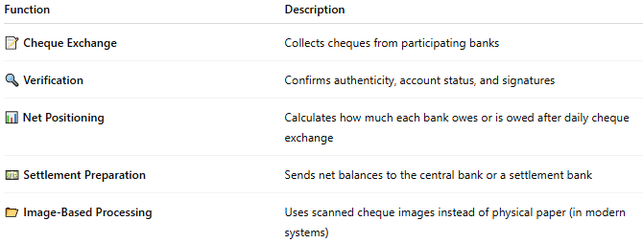

Function | Description
📝 Cheque Exchange | Collects cheques from participating banks
🔍 Verification | Confirms authenticity, account status, and signatures
📊 Net Positioning | Calculates how much each bank owes or is owed after daily cheque exchange
💵 Settlement Preparation | Sends net balances to the central bank or a settlement bank
📂 Image-Based Processing | Uses scanned cheque images instead of physical paper (in modern systems)

🏛️ How the Process Works
# Source: AI Source: Provided by: [Data Path: Persons Table -> ID Column: 1, Name_En Column: Motasem Essam] -> From: [ChatGPT] on [1/21/2026]
- You deposit a cheque at your bank (Bank A).
- Your bank sends the cheque (or its image) to the Cheque Clearing House.
- The Clearing House sends it to the issuing bank (Bank B).
- Bank B verifies the cheque details (funds, signature, etc.).
- If valid, the Clearing House clears the cheque and sends net settlement details to the central bank.
- Funds are then settled between Bank A and Bank B.

🏙️ Examples of Cheque Clearing Systems
# Source: AI Source: Provided by: [Data Path: Persons Table -> ID Column: 1, Name_En Column: Motasem Essam] -> From: [ChatGPT] on [1/21/2026]
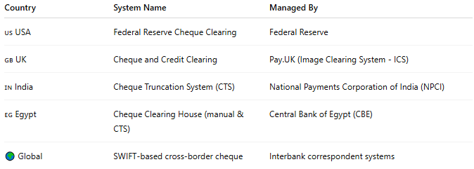

Country | System Name | Managed By
🇺🇸 USA | Federal Reserve Cheque Clearing | Federal Reserve
🇬🇧 UK | Cheque and Credit Clearing | Pay.UK (Image Clearing System - ICS)
🇮🇳 India | Cheque Truncation System (CTS) | National Payments Corporation of India (NPCI)
🇪🇬 Egypt | Cheque Clearing House (manual & CTS) | Central Bank of Egypt (CBE)
🌍 Global | SWIFT-based cross-border cheque | Interbank correspondent systems

📸 Cheque Truncation System (CTS)
# Source: AI Source: Provided by: [Data Path: Persons Table -> ID Column: 1, Name_En Column: Motasem Essam] -> From: [ChatGPT] on [1/21/2026]
Modern clearing uses scanned cheque images to speed up the process.
- No need to physically move cheques between banks.
- Reduces fraud, speeds up settlement, and lowers operational costs.

✅ Benefits of Cheque Clearing Houses
# Source: AI Source: Provided by: [Data Path: Persons Table -> ID Column: 1, Name_En Column: Motasem Essam] -> From: [ChatGPT] on [1/21/2026]
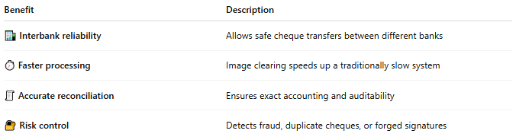

Benefit | Description
🏦 Interbank reliability | Allows safe cheque transfers between different banks
⏱️ Faster processing | Image clearing speeds up a traditionally slow system
🧾 Accurate reconciliation | Ensures exact accounting and auditability
🔐 Risk control | Detects fraud, duplicate cheques, or forged signatures

⚠️ Limitations
# Source: AI Source: Provided by: [Data Path: Persons Table -> ID Column: 1, Name_En Column: Motasem Essam] -> From: [ChatGPT] on [1/21/2026]
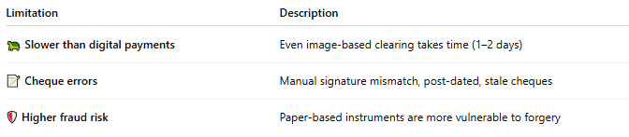

Limitation | Description
🐢 Slower than digital payments | Even image-based clearing takes time (1–2 days)
📝 Cheque errors | Manual signature mismatch, post-dated, stale cheques
🛡️ Higher fraud risk | Paper-based instruments are more vulnerable to forgery

🧠 Summary
# Source: AI Source: Provided by: [Data Path: Persons Table -> ID Column: 1, Name_En Column: Motasem Essam] -> From: [ChatGPT] on [1/21/2026]
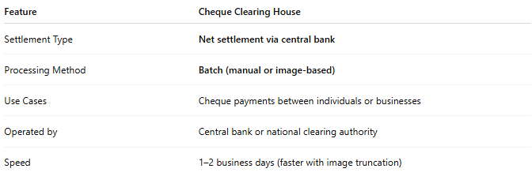

Feature | Cheque Clearing House
Settlement Type | Net settlement via central bank
Processing Method | Batch (manual or image-based)
Use Cases | Cheque payments between individuals or businesses
Operated by | Central bank or national clearing authority
Speed | 1–2 business days (faster with image truncation)

